Effects Guidance
Integration with MSDL

Table of Contents
1 Scope 1
1.1 Identification 1
1.2 References 1
1.3 Overview 1
2 Technical Approach 3
2.1 Doctrinal Basis 4
2.1.1 Schema of Maneuver/Fires 4
2.1.2 High-Payoff Target List (HPTL) 4
2.1.3 Intelligence Collection Plan (ICP) 5
2.1.4 Attack Guidance Matrix (AGM) 6
2.1.5 Target Selection Standards (TSS) 7
2.2 Effects Guidance Schema Extensions to MSDL 8
2.2.1 Effects Guidance 8
2.2.1.1 Proposed Schema 8
2.2.1.2 Issues and Clarification Required (3) 9
2.2.2 Munitions (Attack Systems) 10
2.2.2.1 Proposed Schema 10
2.2.2.2 Issues and Clarification Required (3) 11
2.2.3 Ammunition Allocations 11
2.2.3.1 Proposed Schema 11
2.2.3.2 Issues and Clarification Required (1) 12
2.2.4 High Payoff Target List 12
2.2.4.1 Issues and Clarification Required (None) 12
2.2.5 Target List 12
2.2.5.1 Proposed Schema 12
2.2.5.2 Issues and Clarification Required (2) 14
2.2.6 Target Sets (Relative Value Matrix) 14
2.2.6.1 Proposed Schema 14
2.2.6.2 Issues and Clarification Required (1) 16
2.2.7 Targeting Objectives 16
2.2.7.1 Proposed Schema 16
2.2.7.2 Issues and Clarification Required (None) 17
2.2.8 Attack System Target Pairing 17
2.2.8.1 Proposed Schema 17
2.2.8.2 Issues and Clarification Required (1) 19
2.2.9 Target Selection Standards (TSS) 19
2.2.9.1 Proposed Schema 19
2.2.9.2 Issues and Clarification Required (1) 19
2.2.10 Attack System Guidance 20
2.2.10.1 Proposed Schema 20
2.2.10.2 Issues and Clarification Required (2) 20
2.2.11 Selected Fuse 21
2.2.11.1 Proposed Schema 21
2.2.11.2 Issues and Clarification Required (None) 21
2.2.12 Fuse Properties 22
2.2.12.1 Proposed Schema 22
2.2.12.2 Issues and Clarification Required (None) 22

Table of Figures
Figure 1-1: Command and Staff Processes and Targeting Methodology 1
Figure 1-2: Effects Based Operations Cycle. 2
Figure 2-1: Targeting Products by Echelon (FM 6-20-10) 3
Figure 2-2: High-Payoff Target List 4
Figure 2-3: Attack Guidance Matrix 6
Figure 2-4: Target Selection Standards 7
Figure 2-5: Effects Guidance 8
Figure 2-6: High Payoff Target List 9
Figure 2-7: Target List 10
Figure 2-8: Relative Value Matrix 12
Figure 2-9: Targeting Objectives 13
Figure 2-13: Weapon Target Pair 15
Figure 2-14: Target Selection Standards 16
Figure 2-15: Attack System Guidance 17
Figure 2-16: Selected Fuse 18
Figure 2-17: Fuse Properties 19

Scope

Identification
This document presents a candidate approach for specifying the plan level detail of the targeting process in the Military Scenario Definition Language (MSDL).

References
- MIL STD 2525B Common Warfighting Symbology
- FM 6-20-10 The Targeting Process
- FM 6-71 Fire Support for the Combined Arms Commander Sept 29th, 1994
- FM 6-20-40 Fire Support For The Heavy Brigade Operations
- NEC2AGM.xsd – MATREX provided schema for the attack guidance matrix (starting point)
- fom_v1.0_10MAY2005.omd – MATRIX provided FOM including AGM FOM data.
- C2IEDM – Command & Control Information Exchange Data Model Edition 6.1.
- Effects-Based Operations for Joint Warfighters; Lt. Col. Allen W. Batschelet Field Artillery May-June 2003

Overview
Effects guidance provides top down planning methodology used to “translate the commander’s intent into a plan to decide, detect, deliver, and assess.” Effect guidance provides detail on what to attack, which fire support systems to utilize, how to attack targets in a way that disrupts, delays, or limits the enemy’s ability to achieve his objectives.

Figure 1-1: Command and Staff Processes and Targeting Methodology, depicts the concept of effects based operations as authored by Lt. Col. Allen W. Batschelet Field Artillery May-June 2003. This figure provides insight into how the planning of effects guidance can be used by a simulation to implement commander’s intent. The output of the command and staff process represents the planning decisions in regard to the Scheme of Maneuver/Fires, HPTL, ICP, AGM and TSS. This information is proposed to be captured in MSDL and used by the simulation during rehearsal and execution to detect, deliver and assess.
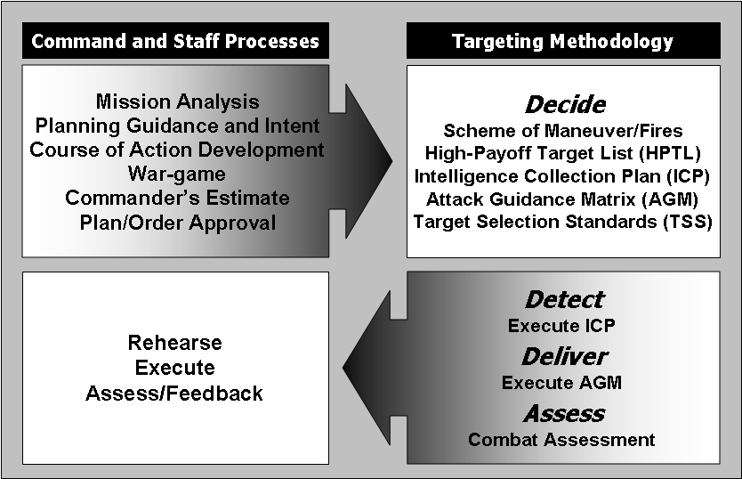
Figure 1-1: Command and Staff Processes and Targeting Methodology
This methodology provides the foundation for the effects based operations cycle depicted in Figure 1-2: Effects Based Operations Cycle.
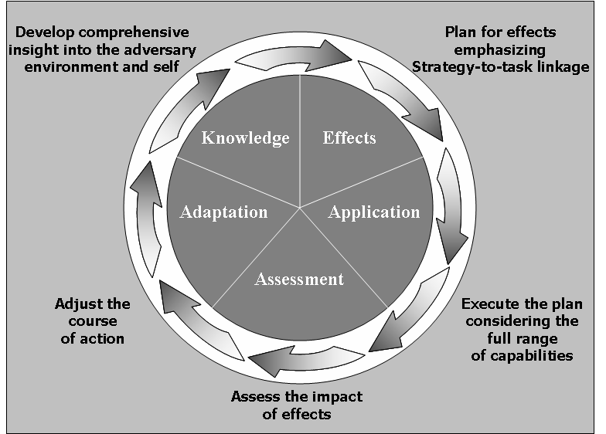
Figure 1-2: Effects Based Operations Cycle.
By this cycle MSDL is applied to the role of knowledge, and the simulation to the roles of effects and application.

Technical Approach
This approach presents a data model of the doctrine specified in FM 6-20-10. This data model provides for much of the content in the planning products developed during the command staff planning processes used for the decide function of the targeting process.

The decide function, as the first step in the targeting process, provides the overall focus and sets priorities for intelligence collection and attack planning. Targeting priorities must be addressed for each phase or critical event of an operation. The decisions made are reflected in visual products. The products are as follows:

- The high-payoff target list (HPTL) is a prioritized list of high-payoff targets (HPTs) whose loss to the enemy will contribute to the success of the friendly course of action.
- The intelligence collection plan answers the commander’s PIRs, to include those HPTs designated as PIR. The plan, within the availability of additional collection assets, supports the acquisition of more HPTs. Determining the intelligence requirements is the first step in the collection management process. For a more detailed description, see FM 34-2.
- Target selection standards address accuracy or other specific criteria that must be met before targets can be attacked.
- The attack guidance matrix (AGM), approved by the commander, addresses which targets will be attacked, how, when, and the desired effects.
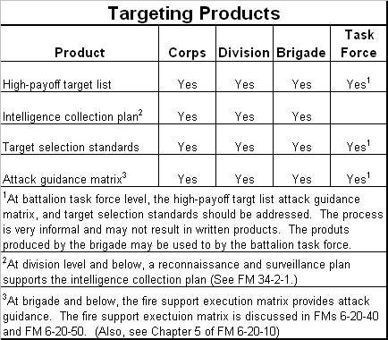
Figure 2-3: Targeting Products by Echelon (FM 6-20-10)
This technical approach presents the planning products of the targeting process, and makes recommendations on how to integrate effects guidance with MSDL. The approach focuses on the complex elements and leaves the specifics to be defined in the MSDL schema. All technical choices made were either adopted from past MSDL decisions, such as using MIL STD 2525B to categorize equipment/platforms/weapons, or were developed from military doctrine to provide clear/unambiguous justification for how to define and structure the proposed MSDL content.

Doctrinal Basis

Scheme of Maneuver/Fires

Relationship to MSDL:
The scheme of maneuvers and fires has already been implemented in the Course of Action data within MSDL.

Recommendation/Justification
Make no changes to MSDL in support of the schema of maneuvers or fires at this time.

High-Payoff Target List (HPTL)
The HPTL is defined in FM 6-20-10. Figure 2-4: High-Payoff Target List was taken from this field manual. The list is specific to a phase/event and depicts the priority, category, target and effect.
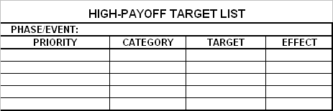
Figure 2-4: High-Payoff Target List
- Phase/Event – Associates the HPTL with a COA (scheme of maneuver), Phase, or Event of the unit’s plan.
- Priority – The relative priority of the target to the mission’s success. Highest priority is 1, with the lowest being 5. See FM 6-20-10 page F-5.
  - Priority 1 – Targets capable of preventing the execution of the plan of action of the ATF or its elements.
  - Priority 2 –Targets capable of immediate serious interference with the plan of action of the ATF or its elements.
  - Priority 3 – Targets capable of ultimate serious interference with the plan of action of the ATF or its elements.
  - Priority 4 – Targets capable of limited interference with the plan of action of the ATF or its elements.
  - Priority 5 – None.
- Category – The target category as specified in appendix A of FM 6-20-10. Each category of targets represents a target set whose
  - C3 – Command, control, and communications.
  - Fire Support – Entire threat fire support system.
  - Maneuver – maneuver tactical subunits in various postures.
  - ADA – Air defense artillery.
  - Engineer – All engineer type targets.
  - RSTA – Reconnaissance, surveillance and target acquisition assets.
  - REC – Radio electronic combat.
  - Nuke/Chemical – Nuclear (NUKE) and chemical support elements and major weapon firing positions.
  - Class III (Fuel) – Petroleum, oil, and lubricants (POL) support.
  - Class V (Ammo) – Ammunition support targets.
  - Class IX (Maintenance) – Maintenance and repair capability.
  - LIFT – Thread force transport units.
  - LOC – Lines of communication.
- Target – The description of the target or type of target.
- Affect – Goal or targeting objective that specifies why a target is to be attacked (intent). Affects can be to Limit, Disrupt, Delay, Destroy, or Damage the target. Combining this objective with a prosecuting fire support system and duration of effects provides for the effect on enemy forces (suppress, neutralize, destroy, harass).
  - Limit enemy capabilities applies to reducing the options or courses of action available to the enemy commander.
  - Disrupt enemy plans by precluding effective interaction or the cohesion of enemy combat and combat support systems.
  - Delay alters the time of arrival of forces at a point on the battlefield or the ability of the enemy to project combat power from a point on the battlefield.
  - Destroy calls for ruining the structure, organic existence, or condition of an enemy target that is essential to an enemy capability.
  - Divert an interdiction objective which addresses the commander’s desire to tie up critical enemy resources.
  - Damage reflects a subjective or objective assessment of battle damage.

Relationship to MSDL
FM 6-20-10 indicates in the description of the Decide function that the HPTL is relative to the decision support template (DST) as part of the commander’s critical information requirements (CCIR). MSDL currently associates the DST with each COA and phase of the scenario. See FM 6-20-10 page 1-6.

Recommendation/Justification
Include the HPTL as effects guidance in MSDL, related directly to each COA and COA Phase.

Intelligence Collection Plan (ICP)

The collection plan provides a framework that collection managers use to determine, evaluate, and satisfy intelligence needs. Because of the diversity of missions, capabilities, and requirements, the collection plan has no prescribed doctrinal format. However, a dynamic collection plan should:

- Have as its basis the commander’s priority intelligence requirements, to include those HPTs approved as PIRs.
- Help the commander see his area of interest.
- Provide synchronized coverage of the commander’s area of operations.
- Have a five-dimensional battlefield approach: width, length, depth or altitude, time, and electromagnetic spectrum.
- Cover the collection capabilities of higher and adjacent units. Identify assets for acquiring and tracking HPTs and determining BDA on HPTs.
- Be flexible enough to allow response to changes as they occur.
- Cover only priority requirements.
- Be a working document.
- Contain precise and concise information.

Relationship to MSDL
The intelligence collection plan is represented by the specification of High-Payoff Targets.

Recommendation/Justification
Limit the ICP to the High-Payoff Target List. The intelligence collection plan is considered too dynamic to include in its entirety. However, aspects of the ICP such as the High-Payoff Targets can be included. It is not anticipated that this limitation will cause any problems since today’s simulations are neither sufficiently adaptive to focus intelligence on prioritized information requirements, nor to use the information to adjust the plan if it was collected.

Attack Guidance Matrix (AGM)
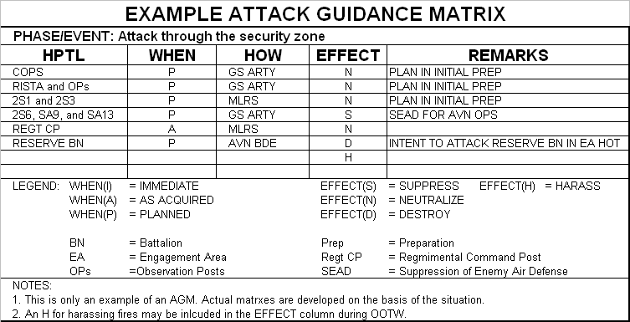
Figure 2-5: Attack Guidance Matrix
- Phase/Event – Associates the AGM with a COA (scheme of maneuver), Phase, or Event of the unit’s plan.
- HPTL – Identifies the target (description)
- When – Identifies when to attack as immediate, as acquired, or planned.
- How – Identifies the prosecuting fire support system or unit to attack the target.
- Effect – Effects of attack on the enemy can be to harass, suppress, neutralize, or destroy the target. The affect is provided for by matching the proper attack system and durative of effect (prosecuting elements) with the target.
  - Harassing fire (JP 1-02) is fire designed to disturb the rest of enemy troops, to curtail movement and, by the threat of losses, to lower morale.
  - Suppression fires (JP 1-02) are fires on or around a weapons system, to degrade its performance below the level needed to fulfill its mission objectives.
  - Neutralization fires (JP 1-02) are delivered to render the target ineffective or unusable for a temporary period.
  - Destruction fires physically render the target permanently combat-effective or so damaged that it cannot fiction unless it is restored, reconstituted, or rebuilt. Setting automated fire support default values for destruction of 30 percent does not guarantee the achievement of the commander’s intent.

Note: The term Effect in FM 6-20-10 was modified to Affect in context to the AGM. The rationale was to distinguish between Affect (Limit, Disrupt, Delay, Destroy, or Damage) of attack and the intend Effect (harass, suppress, neutralize, and destroy) the attack would have on the enemy.

Relationship to MSDL
The scheme of maneuvers and fires is already implemented in the Course of Action data within MSDL.

Recommendation/Justification

Target Selection Standards (TSS)
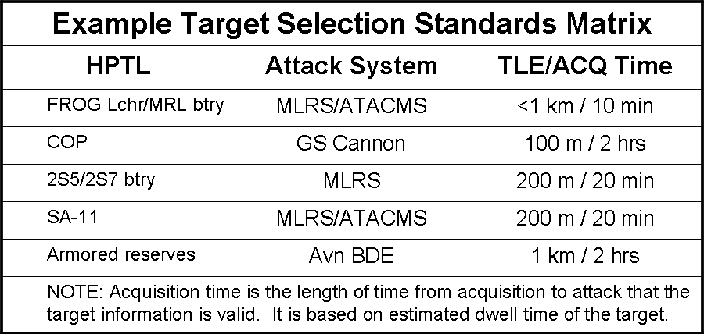
Figure 2-6: Target Selection Standards

Effects Guidance Schema Extensions to MSDL
Effects guidance applies to MSDL in two manners. The first is represented in the decide function of the targeting process. During the decide function, targeting guidance and planning products are produced that determine how a COA is to be executed. The following products are created during this function:

- High-Payoff Target List (HPTL) – This list identifies the targets, their priority and target category.
- Attack Guidance Matrix (AGM) – This matrix matches targets up to weapon (attack) systems and the target selection standards.
- Target Selection Standards (TSS) – These standards specify the target location error, size of enemy activity (foot print as point or area), status of activity (moving or stationary), and timeliness of the information (acquisition time).

Second, the targeting process includes documentation on the situation such as target acquisition detail. This has implications to the military situation as documented in MSDL. This secondary relationship to MSDL is not accounted for in this proposed extension.

Effects Guidance
Effects guidance provides a computational translation of commander’s intent that can be used by a simulation to execute that guidance/intent.

Proposed Schema
The proposed approach to integrating effects guidance with MSDL is to make this element subordinate to the Course of Action and COA Phase to align integration with the Decision Support Template (DST).
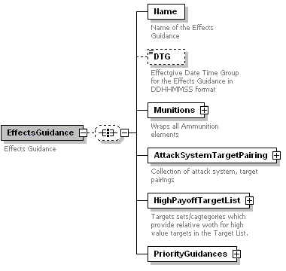
Figure 2-7: Effects Guidance

Type: Complex Element

Subordinate Elements
- Name – The name of the effects guidance data.
- DTG – The date time group of the effects guidance.
- High-Payoff Target List – Group/collection of (high payoff) targets and target sets. This information identifies the targets by value and category.
- Munitions – Group/collection in MSDL of categories of ammunition and weapon systems. This information specifies what to engage targets with.
- Attack System Target Pairing – Group/collection in MSDL what Munitions entries to be paired against specific high payoff targets.
- Priority Guidance – TBD

Issues and Clarification Required (3)
- Priority guidance has no underlying structures. It is known how this is intended to be used. Need clarification from MATREX.
- Effects guidance appears to rely on past target acquisition detail. Dwell time, decay time and acquisition time appear to relay on the specific time relative to scenario start of when the target was acquired.
- Effects guidance appears to rely on logistics information concerning the attack systems and munitions. Attack systems are only covered by 2525B symbol IDs, but this detail does not appear to be sufficient. Munitions are not provided for outside of effects guidance at all.

Munitions (Attack Systems)
As targets are developed, appropriate attack systems are tasked in accordance with the attack guidance and location requirements of the system. The main objective of the deliver function is the attack of targets in accordance with the attack guidance. The tactical solution (the selection of an attack system or a combination of systems) leads to a technical solution for the selected systems.

Proposed Schema
The proposed approach for attack systems is to integrate based on the munitions which provide for the battlefield effects. The justification/rationale is that the delivery mechanisms (platforms) will vary, but the effects remain correlated to the munitions, not the delivery system.
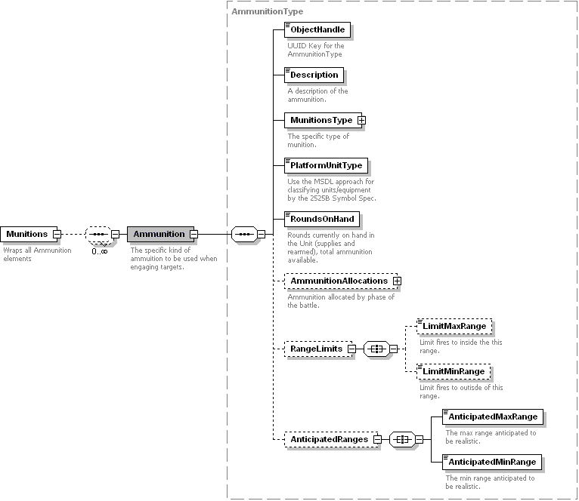
Figure 2-8: Munitions (Attack Systems)

Type: Complex Element

Subordinate Elements
- Object Handle – The UUID reference to the attack platform/unit/munitions combination representing an attack system.
- Description – The description of the attack system.
- Munitions Type – The type of munitions to be used by the unit/platform.
- Platform/Unit Type – The type of unit or platform to be employed as the attack system.
- Rounds on Hand – Rounds on hand (munitions) by the task organization.
- Ammunition Allocations – The allocation thresholds for each phase of the COA.
- Range Limits – The range limit constraints being applied to the attack system.
- Anticipated Ranges – The anticipated ranges for which the attack system is expected to be employed.

Issues and Clarification Required (3)
- From a doctrinal perspective, it would appear that the attack system would be more appropriate name for this data rather than the munitions fired by the system. The munitions appear to be guidance on how to employ the attack system.
- Rounds on Hand appear to be in conflict with the nature of “Effects Guidance”. This information relates to logistical status and does not reflect guidance.
- Ammunition Allocations – The Effects Guidance is applied to COAs and/or phases, but the ammunition allocations are partitioned by phase. This works for the COA level, but not for the Phase. Additionally this is logistical information which does not seem consistent with the nature of effects guidance. Additional domain analysis may be required.

Ammunition Allocations

Proposed Schema
The proposed schema for specifying how ammunition is to be allocated over time is to specify the required percentage of ammunition that is to remain at the end of each phase.
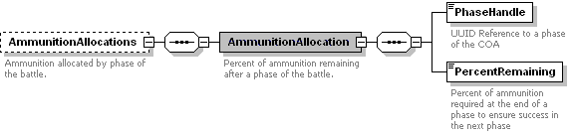
Figure 2-9: Ammunition Allocations

Type: Complex Element

Subordinate Elements
- Phase Handle – The UUID reference to the phase to which the allocation is specified.
- Percent Remaining – The percent of original rounds on hand that are to remain at the end of the phase.

Issues and Clarification Required (1)
- This data structure allows for conflicts that cannot be validated by the MSDL schema. One phase’s percent remaining can be smaller than the subsequent phase, and the sum total can exceed 100%. Also, this approach does not account for re-supply.

High Payoff Target List
The high-payoff target list (HPTL) is a prioritized list of high-payoff targets (HPTs) whose loss to the enemy will contribute to the success of the friendly course of action.

The high-payoff target list identifies the list of all targets and associates the targets with the doctrinally correct set of target categories (target sets).
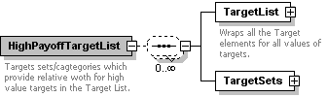
Figure 2-10: High Payoff Target List

Type: Complex Element

Subordinate Elements
- Target List – The list of all targets which reference the category or target set to which they belong.
- Target Sets – The 13 target sets or categories identified in FM 6-20-10.

Issues and Clarification Required (None)
- None

Target List
Those assets the enemy commander requires for the successful completion of his mission are HVTs. The loss of HVTs would be expected to degrade important battlefield functions.

Proposed Schema
The target list identifies all high value targets independent of whether they represent high-payoff targets or not. Each HVT is identified as a HPT by the associated target set. Each HVT is identified at the three levels of Classification, Recognition, and Identification. These levels of identification are provided for by the 2525B symbol codes. This classification scheme has been modified to represent a symbol spec or pattern that can be used to determine a match to a specific symbol id.
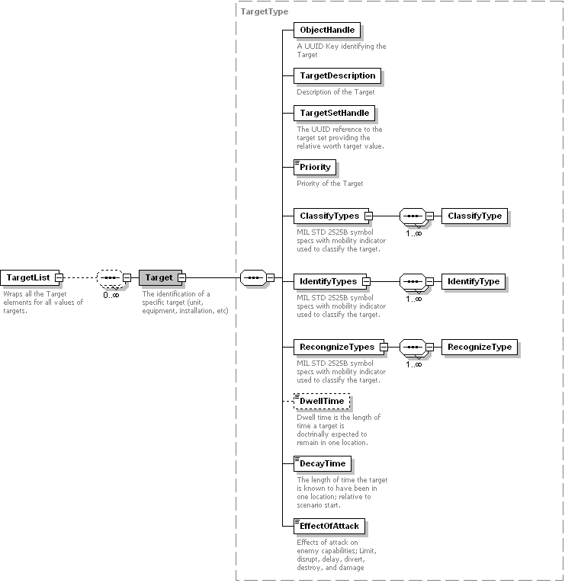
Figure 2-11: Target List

Type: Complex Element – Target Type

Subordinate Elements
- Object Handle – Universal unique identifier of each target.
- Target Description – The human readable target name or description.
- Target Set Handle – The UUID reference to the target set to which the target belongs.
- Priority – The priority of each target in the list. This value is used to order the targets in the attack guidance matrix in priority order. While the doctrine establishes five basic levels of priority, these five values don’t provide for the explicit ordering of targets.
- Classify Types – The general classification of the target using MIL STD 2525B symbol specifications to include mobility modifiers.
- Identify Types – The MIL STD 2525B symbol specifications to include mobility modifiers used to identify the target.
- Recognize Types – The specific MIL STD 2525B symbol specifications to include mobility modifiers used to recognize the target.
- Dwell Time – Dwell time is the length of time a target is doctrinally expected to remain in one location.
- Decay Time – The length of time the target is known to have been in one location; relative to scenario start.
- Effect of Attack – Effects of attack on enemy capabilities; Limit, disrupt, delay, divert, destroy, and damage.

Issues and Clarification Required (2)
- By the doctrine dwell time appears to be target reporting detail. Other such detail is missing from the data model to include:
  - Reporting agency – Missing
  - Date-time group (DTG) of acquisition by the sensor – Missing
  - Description of the activity – Missing
  - Size of the target – Size of Activity is part of TSS but not of target size is not provided for.
  - Target location and altitude – Missing.
  - TLE – Part of TSS, but not of the specific target.
  - Dwell time – Provided for.
  - Status (stationary or moving). – Provided for.
- Dwell time and decay time appear to represent a conflict in the domain of the target data. Decay time includes target reporting detail, which appears to be out of scope for a target type (in scope for a specific instance of a target).

Target Sets (Relative Value Matrix)
High value targets (HVT) which, if successfully attacked, would contribute substantially to friendly operations are called high-payoff targets (HPT). The association of a target category, which includes the target value (type) provides for the elevation of a HVT as a HPT. Target sets represent a methodology for target value analysis by providing a relative ranking between target sets, or categories. There are 13 categories covering the major battlefield functions.

Proposed Schema
The target sets combined with a relative work for each category is used to distinguish the priority and value of the targets.
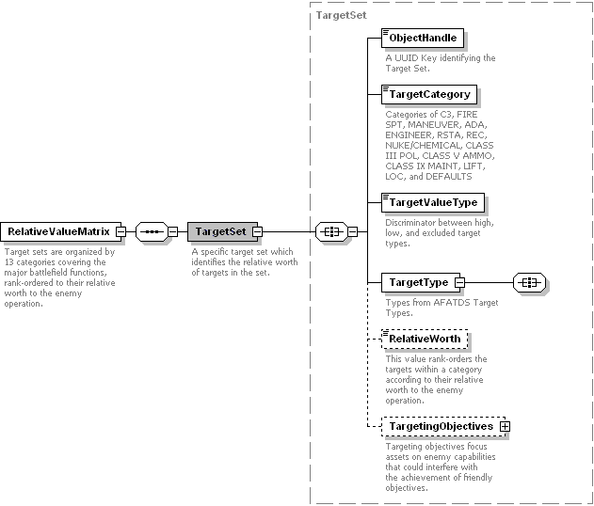
Figure 2-12: Relative Value Matrix

Type: Complex Element – Target Set

Subordinate Elements
- Object Handle – Universal unique identifier of each target.
- Target Category – The 13 target categories of Categories of C3, FIRE SPT, MANEUVER, ADA, ENGINEER, RSTA, REC, NUKE/CHEMICAL, CLASS III POL, CLASS V AMMO, CLASS IX MAINT, LIFT, LOC, and DEFAULTS.
- Target Value Type – Discriminator between high, low, and excluded target types.
- Target Type – TBD
- Relative Worth – In the relative value matrix, the target sets are rank-ordered according to their relative worth to the enemy operation. The worth only to indicate the ordering of sets compared with one another. The target sets that are not considered high-value are not assigned a value.
- Targeting Objectives – Targeting objectives focus friendly assets (attack systems) on enemy capabilities that could interfere with the achievement of friendly objectives.

Issues and Clarification Required (1)
- Target Type has no clear doctrinal definition. This appears to be specific to the targeting system (application) such as AFATDS.

Targeting Objectives
The articulation of targeting objectives as it relates to limited manpower and resources will require a command analysis, as much for what the targeting objective does not mean as for what it does. Targeting objectives are used to guide the decision of how to use attack systems effects to affect the enemy in a deliberate manner.

Proposed Schema
The targeting objects specify the effects that attack systems will provide in context to a specific category of target. These effects are specified in FM 6-20-10.
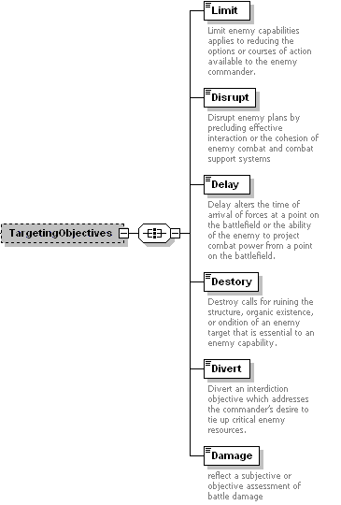
Figure 2-13: Targeting Objectives

Type: Complex Element

Subordinate Elements
- Limit – Designates the objective to limit enemy capabilities applies to reducing the options or courses of action available to the enemy commander. For example, the commander may direct the use of air interdiction and fire support to limit the use of one or more avenues of approach available to the enemy. Also, he may direct the use of interdiction to limit enemy use of fire support capability.
- Disrupt – Designates the objective to disrupt enemy plans by precluding effective interaction or the cohesion of enemy combat and combat support systems. In regard to Air Force interdiction doctrine, disrupt forces the enemy into less efficient and more vulnerable dispositions.
- Delay – Designates the objective to delay or alters the time of arrival of forces at a point on the battlefield or the ability of the enemy to project combat power from a point on the battlefield. In interdiction doctrine, delay results from disrupting, diverting, or destroying enemy capabilities or targets.
- Divert – Designates the objective to divert is an interdiction objective which addresses the commander’s desire to tie up critical enemy resources. Attack of certain interdiction targets may result in the enemy commander’s diverting capabilities or assets from one area or activity to another. Divert indirectly reduces the capability of the enemy commander to continue his plans.
- Destroy – Designates the objective to destroy as an interdiction objective calls for ruining the structure, organic existence, or condition of an enemy target that is essential to an enemy capability. Describing destruction as an objective requires establishing specific quantities or percentages within the ability of the weapon system or systems. For example, artillery normally uses 30 percent as the criteria for destruction, whereas maneuver combat forces typically use 70 percent.
- Damage – Designates the objective to can be used to reflect a subjective or objective assessment of battle damage or to describe nuclear targeting objectives (light) moderate, or severe). Light, moderate, or severe damage are terms associated with nuclear target analysis commander’s criteria for desired affect on the enemy.

Issues and Clarification Required (None)
- None

Attack System Target Pairing
The paring of attack system with targets, and guidance on how to employ those systems in terms of battlefield effects, is used to affect the enemy in a deliberate manner.

Proposed Schema
Attack System and Target Paring provides an integration point for targets and attack system to include the targeting guidance of target selection standards and attack system guidance. Additionally this element provides for identifying the indented affect the attack system is to have on the enemy when being employed against the target as specified in the guidance.
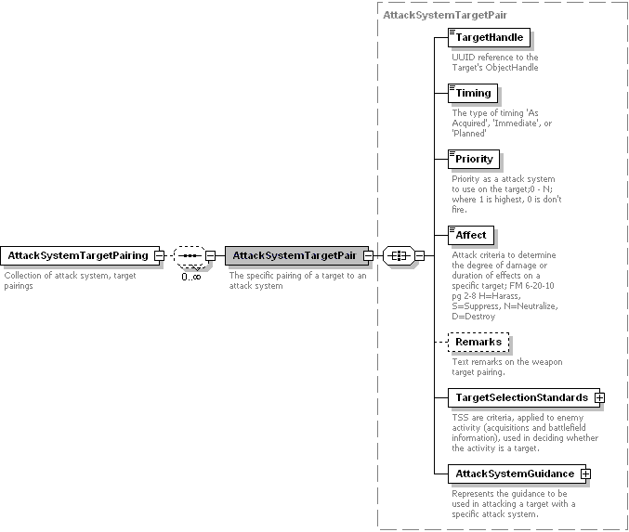
Figure 2-14: Weapon Target Pair

Type: Complex Element – Attack System Pair

Subordinate Elements
- Target Handle – A UUID reference to a target (type).
- Timing – The current implementation matches the doctrine (FM 6-20-10) “As Acquired", "Immediate", or "Planned”
- Priority – Because more than one attack system can be paired with a target, this priority provides guidance on which attack system pair takes priority over another.
- Affect – FM 6-20-10 Attack criteria to determine the degree of damage or duration of effects on a specific target; FM 6-20-10 pg 2-8 H=Harass, S=Suppress, N=Neutralize, D=Destroy
- Remarks – General remarks or guidance on attacking the target.
- Target Selection Standards (TSS) – Addresses the accuracy or other specific criteria that must be met before targets can be attacked.
- Attack System Guidance – Represents the guidance to be used in attacking a target with a specific attack system. This includes the munitions, fuse types, number of attack systems, rounds to fire, etc (effects) which affect the enemy in a deliberate manner.

Issues and Clarification Required (1)
- Need to consult military domain experts (SME) on targeting to verify/validate the use of the term “Affect” in this context.

Target Selection Standards (TSS)

Proposed Schema
The target selection standards provide the detail necessary to distinguish between targets to be engaged and candidate targets. Candidate targets represent targets which need additional CCIR before the benefit of attacking them can be determined.
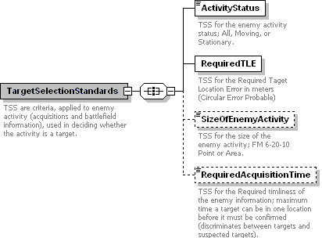
Figure 2-15: Target Selection Standards

Type: Complex Element

Subordinate Elements
- Activity Status – Both MC2 and FM 6-20-10 define this as Moving and Stationary. MC2 additionally includes “All” to represent both activities are occurring.
- Required Target Location Error (TLE)
- Size of Enemy Activity – Point or Area indicating the target is centralized or dispersed.
- Required Acquisition Time – The required timeliness of the enemy information as the maximum time a target can be in one location before the target must be confirmed again. This detail is used to discriminate between targets (selected) and sus

Issues and Clarification Required (1)
- Need to consult military domain experts (SME) on targeting to verify/validate the content of the TSS data.

Attack System Guidance
Attack system guidance provides details on the effects to be delivered by an attack system on a target in order to achieve the desired affect on the enemy’s operations.

Proposed Schema
The schema approach for Attack System Guidance is to include detail on how to
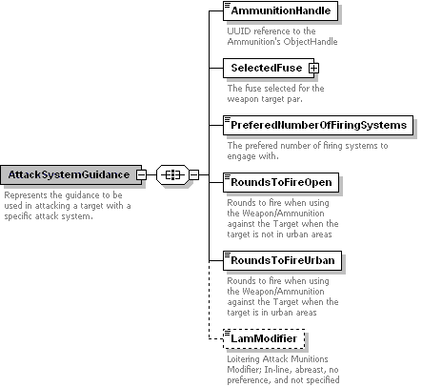
Figure 2-16: Attack System Guidance

Type: Complex Element

Subordinate Elements
- Ammunition Handle – The UUID reference to the ammunition to be used when employing an attack system against a target.
- Selected Fuse
- Rounds to Fire Open
- Rounds to Fire Urban
- Loitering Attack Munitions Modifier

Issues and Clarification Required (2)
- Need to consult military domain experts on targeting to verify/validate the name assigned to this element.
- Need verification on the LAM Modifier to confirm the doctrinal basis for this element.

Selected Fuse
The selected fuse provides guidance on how the munitions are to be delivered and timed.

Proposed Schema
The approach used here is based on the command and control information exchange data model. The C2IEDM fuse types and properties were used to define the Fuse Properties as a choice of fuse type specific elements each including the associated properties
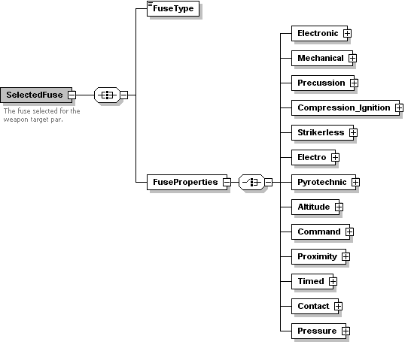
Figure 2-17: Selected Fuse

Type: Complex Element

Subordinate Elements
- Fuse Type – The type of fuse from C2IEDM.
- Fuse Properties – The type specific fuse properties as represented in the C2IEDM.

Issues and Clarification Required (None)
- None

Fuse Properties

Proposed Schema
The approach used here is based on the command and control information exchange data model. The C2IEDM fuse types and properties were used to define the Fuse Properties as a choice of fuse type specific elements each including the associated properties.
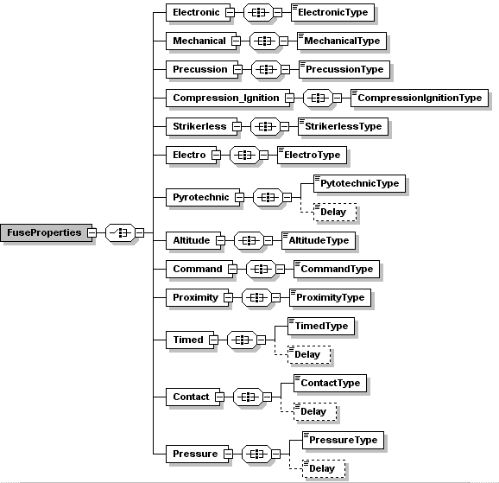
Figure 2-18: Fuse Properties

Issues and Clarification Required (None)
- None

Preface to “The Targeting Process” FM 6-20-10, May 8th, 1996.

